Name: Krithi A

Reg no:113323106054

Dept: ECE – B

NM Id:aut113323eca27

Phase 5: Project Development and Documentation

Title**:** Autonomous Line-following robot for College campus

INDEX

**S.NO TITLE PG.NO**

1. **PROJECT DEMONSTRATION 2**
2. **PROJECT DOCUMENTATION 2**
3. **FEEDBACK AND FINAL ADJUSTMENTS 3**
4. **FINAL PROJECT REPORT SUBMISSION 3**
5. **PROJECT HANDOVER AND FUTURE WORKS 4**
6. **CODE WITH OUTPUT 5-9**

**Abstract:**

This project presents the design and development of an autonomous line-following delivery robot aimed at improving the efficiency of intra-campus goods transport. The robot follows a pre-defined line path using IR sensors and delivers items to designated locations such as departments, labs, and offices. This solution reduces human effort, streamlines small parcel delivery, and offers a reliable autonomous navigation system tailored for a campus environment.

1. Project Demonstration

**Overview:**

The project demonstration showcases the robot navigating along marked paths to complete delivery tasks within a college campus.

**Demonstration Details:**

* The robot follows black tape using IR sensors.
* Stops at checkpoints using RFID or color codes.
* Delivers items using a small mechanical compartment.
* Avoids obstacles using ultrasonic sensors.

**Outcome:**

A successful demonstration highlights the robot’s autonomous navigation, delivery precision, and its potential to reduce human workload in campus logistics.

2. Project Documentation

**Overview:**

Complete documentation ensures reproducibility, understanding, and future improvements of the project.

**Documentation Sections:**

* Introduction and objectives
* Components and block diagram
* Circuit design and working
* Programming logic and flowcharts
* Testing methodology
* Results and analysis

**Outcome:**

A well-documented project serves as a reference for academic reviews, technical audits, and future enhancements.

3. Feedback and Final Adjustment

**Overview:**

After initial testing, feedback is collected to fine-tune the performance and functionality of the robot.

**Steps:**

* **Feedback Collection**: From faculty, students, and users.
* **Refinement**: Based on battery life, sensor response, and delivery accuracy.
* **Final Testing**: Verifies stability and reliability in real-world scenarios.

**Outcome:**

An optimized robot that is user-friendly, accurate in deliveries, and more efficient based on real-time input.

4. Final Project Report Submission

**Overview:**

The final report compiles all stages of development, testing, and review in a structured format.

**Report Sections:**

**Executive Summary:** A concise summary highlighting the objective, approach, and key outcomes of the project. It outlines how the robot addresses delivery needs within the campus effectively.

**Phase Breakdown:**

* Problem identification
* Research and design thinking
* Technical development
* Testing and feedback
* Final deployment

**Challenges and Solutions:**

Describes major challenges (e.g., sensor calibration, navigation issues, user acceptance) and how each was addressed during the development process.

**Outcome:**

A comprehensive report that reflects the project's complete lifecycle and demonstrates its academic and practical value.

5. Project Handover and Future Works

**Overview:**

The robot is handed over to the institution for use or future development, with documentation and guidance.

**Handover Details**:

* Code and documentation shared via repository/drive.
* User manual and maintenance guide provided.
* Demo session for the next user team.

**Outcome:**

Smooth transition for future upgrades or deployment, and foundation for more advanced campus robotics solutions.

Python code for phase 5:

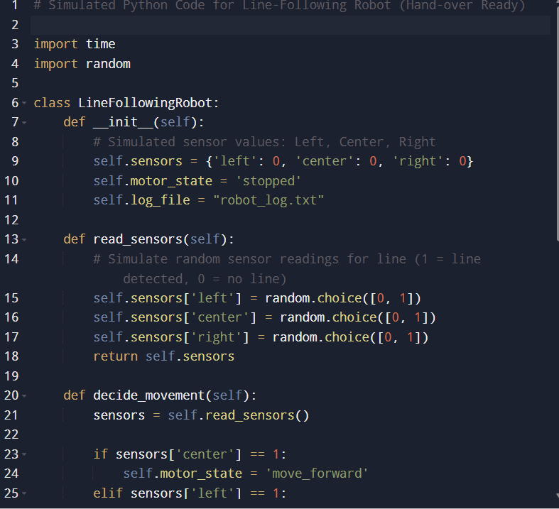

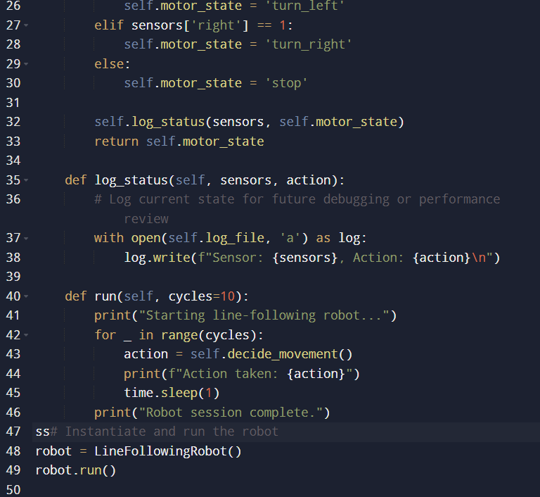

Output:

Console output:

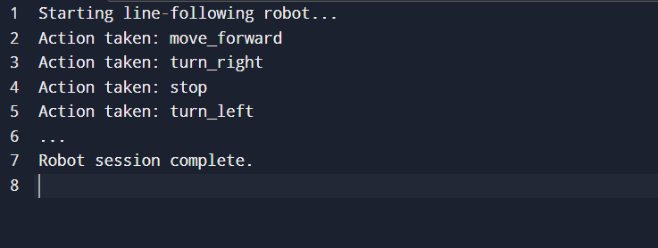

robot_log.txt:

